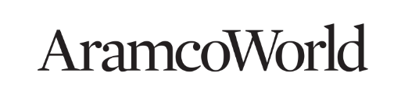
Freelance Contributor Feature Story Proposal

Before submitting the proposal, please make sure you have read AramcoWorld’s Guidelines for Contributors
Date:
Name and contact email (if submitting as a reporting team, include contacts for all team members):
Address and phone number:
Please select:
- Length (Example: 800 words, 1,500 words, 2,000 words):
- Category (Example: Arts, Food, History):
PLEASE RESPOND TO THE FOLLOWING BRIEFLY (one or two sentences for each):
What is the story/topic you are proposing?

What is the specific angle/question you’d like to center your story around?

What are the components of this story? (elements, proposed interviews…?)

Why do you want to focus on this topic now?

Describe its significance to AramcoWorld’s global audience.

How will this story be illustrated? (Please specify the types of visuals—photography, illustrations, etc.)

Please indicate your proposed delivery date and any travel requirements:

*If you have not worked with AramcoWorld before, help us get to know you. Feel free to add your website or LinkedIn profile, and send links to your writing samples.
**When finished, please save as “Freelance proposal_[your name]_[story slug]” in MSWord (.docx).
Email to storypitch@aramcoamericas.com

